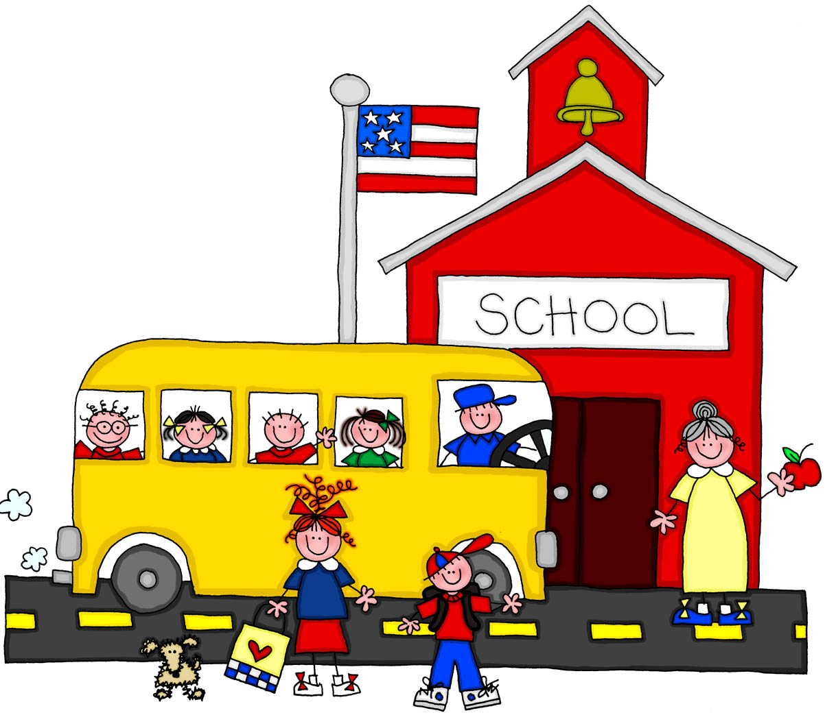
Second Grade News
December 4-8, 2017

Our learning Targets for the week –
Math – Addition and Subtraction Strategies
ELA – Shared Reading

Spelling pattern: Soft c and g
List A: ice,germ, face, digit, price, age,fancy, large, dance, cage, circus, choice, orange, angel, giant
List B: celebrity, certificate, embrace, graceful, parcel, officer, cottage, geometry, luggage, package, circus, choice, orange, angel, giant
Science:
Matter
Social Studies:
Creek and Cherokee Cultures

IMPORTANT DATES -

December- 21st Christmas Party/ Last day before Christmas Break

We are collecting for Wildwood Nursing Home residents for Christmas…….please see list on back for donations.

Please send jackets, hats, gloves, etc with students daily. We go out if it is above 42 degrees……..Thanks!

We will be celebrating Red Ribbon Week next week (Oct 30-Nov 3)

Dress up days/themes are as follows.
Monday- My future is so bright I need to wear shades. (wear sunglasses)
Tuesday- Don't let drugs make your life scary. Wear a HAPPY Halloween Costume- NO MASKS, FACE PAINT, GORE, or SCARY things.
Wednesday- Give drugs the boot. Wear your cowboy boots.
Thursday- Don't be a target for drugs- Dress in Camouflage.
Friday- I am too smart for drugs. Dress like what you want to be when you grow up.

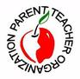
~~~~More INFO on the back~~~~

Hill City is fortunate to have a wonderful and supportive PTO.
They have many new and exciting activities planned for our families this year.
Please consider joining with a $5.00 donation per family.
Thanks for your support!

@HillCityHawks

Hill City Elementary and Hill City Elementary PTO

Suggested Websites
https://www.mobymax.com/signin - All Subject Areas – We use this at school too.
www.commoncoresheets.com (print out sheets to complete)
www.raz-kids.com (stories to read)
www.ixl.com (math practice)
www.xtramath.org (great place to study addition facts)
www.kidrex.com (kid friendly search engine)
www.lexile.com (see appropriated level books for your reader)
www.storylineonline.net (listen to stories)
www.readworks.org (print stories with questions for comprehension)
www.kids.nationalgeographic.com

*If you provided an email address you will not receive a newsletter in your child’s folder. Newsletters are posted on teacher websites.
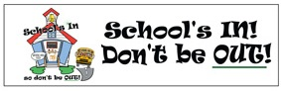
School Vision Statement:
Graduation and life preparation for all.

Questions? Concerns?
deanasutton@pickenscountyschools.org
bethromesberg@pickenscountyschools.org
kellyproudfoot@pickenscountyschools.org
hollyellis@pickenscountyschools.org

